International Student Guide

Information about Indian Student VISA
Indian Student Visa is granted to individuals who wish to come to India and study at a recognized educational institution. Students should apply for the student visa after they receive an admission letter from the Indian educational institution. Indian Missions/Embassies under the Government of India will grant the Indian Student Visa to foreign nationals who wish to pursue the following:
- Regular, full-time, structured courses at educational institutes duly recognised by the statutory regulatory body in India.
- Short-term courses and student exchange programmes.

For more information, please check here

How to apply for VISA
Applicants are required to fill an online visa application by visiting the website and then visit their nearest embassy with a printout of the online filled application and required travel documents.
Processing time for Visa applications can vary from several days to few weeks. It would be advisable to apply for your Visa as soon as possible.

Information about FRRO process:
FRRO stands for Foreigners Regional Registration Office. All foreigners including foreigners of Indian origin visiting India on long term student visa are required to get themselves registered with the Foreigners Regional Registration Officer (FRRO)/Foreigners Registration Officer (FRO) concerned within 14 days of arrival in India. You can check detailed information on this at Government of India, Ministry of External Affairs website. You can also check additional information here
People visiting India on Student Visa(S) (including those coming for the study of Yoga, Vedic Culture, the Indian system of dance and Music), Research Visa(R), Medical Visa(M) or Medical Attendant (MED-X) Visa and Employment Visa(E) valid for more than 180 days are required to get themselves registered with concerned FRRO, within 14 days of the first arrival, irrespective of the duration of the stay.
Below are some general documents required for the FRRO application process:
- Passport – Photo page and page indicating validity
- Indian VISA and Page bearing Immigration Stamp on arrival in India
- Residence proof in India –Your Hotel / Service Apartment/College Hostel needs to fill the FORM C and provide you with a copy of the same. For more information check here
- NRO (Non Resident Ordinary) – You can get your/your parent’s bank account statement indicating availability of sufficient funds to take care of your expenses in India
- Passport size colour photo in .jpg format. Recent front facing photograph with white background is required
- Insurance copy

Applicants need to upload all the documents on the FRRO portal.

Students also need to buy a valid mobile number/connection in India for obtaining the One Time Password (OTP) during this FRRO registration. Thus, it is advisable to get for yourself an Indian mobile connection as soon as possible on arrival in India

For more information, please check here:

NMIMS Hostel accommodation Facility / Accommodation in private shared apartments:
Students can book their accommodation at NMIMS hostel if they wish. Please check here for more information. For any further queries, students may contact Mr. Venugopal K., Assistant Registrar, NMIMS (Administration).
Students who wish to take accommodation in NMIMS Hostel can apply through NMIMS hostel application portal https://portal.svkm.ac.in/usermgmt/viewHostels
Information related to FORM C: As per the rules, the owner of the place where you would stay in India needs to complete and submit the Form C within 24 hours of your arrival at your place of accommodation. Please check with your owner of accommodation on this. Form C should be provided to you by the Hotel / Service apartment / Guest House / Individual House owner / etc where you would be staying.
If you choose to stay at NMIMS Hostel accommodation, we would provide you with the Form C.
Private shared apartments: For those who wish to stay in private shared apartments, Mumbai has a lot of options. Some apartments are fully furnished, others come without furniture. You should look for booking a place in the following parts of the Mumbai city: Vile Parle (East/ West), Juhu, Andheri (West), Bandra (West). These locations are close to SVKM’s NMIMS Mumbai campus. Here are some useful links for finding accommodation:
https://www.airbnb.co.in/ www.magicbricks.com www.makaan.com www.99acres.com

Phone and Internet:
Local mobile connection may cost you around 300 to 1000 INR per month depending on your usage. Below are the few service providers for your reference:
https://www.jio.com/ https://www.airtel.in/ https://www.vodafone.in/home-mumbai?section=consumer

Insurance:
Purchasing a valid health insurance / medical insurance coverage is the responsibility of the student. Having a valid coverage is a prerequisite to register for classes. Students are required to share the list of hospitals in Mumbai their insurance company has tied up with. This information would be helpful during medical emergency.

Food Expense:
SVKM’s NMIMS Canteen is the winner of Students Choice 2016 for College with Best Canteen by Collegesearch. Students can have Breakfast, Lunch and Dinner at approximately INR 500 to 1000 / day in the college canteen. Alternatively, there are good hotels/restaurants nearby.
Local Travelling:
Students can hire an Auto rickshaw (easily available and economical) for short distances. For longer distances students can hire a local Taxi or online cab aggregator like Uber/Ola (preferred). Students can also explore the suburban Train system and the Metro service.
In-campus Doctor
NMIMS University has the below on campus Doctors:
- Dr. Harish Dhuri
- Dr. Ushma Vikram Mashru
The Dispensary is located at ground floor of Mithibai College Building near Gate No-4.
All students can consult the Doctor located on campus. To avail this facility as and when required, one must carry the Student ID Card while visiting the dispensary.
In case of assistance required in consulting the Doctor, kindly contact Mr. Prashant Shirke, prashant.shirke@nmims.edu from the NMIMS administration Department.
Please find the route map to visit the dispensary at Mumbai campus:
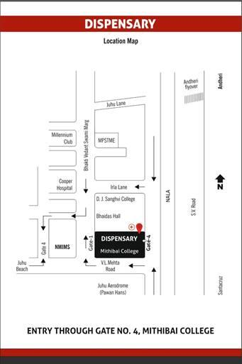

Point of Contact at Department of International Linkages:
For any assistance required, students can contact Ms. Shweta Patil, Manager - International Linkages Department at shweta.patil@nmims.edu : Landline - +91 22 4235 2263

